SUMMER VITERBO STUDENT EMPLOYMENT APPLICATION INSTRUCTIONS

- Go to https://www.viterbo.edu/advising-and-career-development/handshake and click on the Handshake logo at the top of the page.

- Log into Handshake using your Viterbo email and password. If you are new to Handshake, the system will prompt you to fill out your profile. A video explaining this process is on the career services Handshake page under the Students section, called “Sign in for the First Time.”
- Once you are logged in, click on “Jobs” in the left menu.
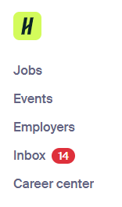
- Choose “All filters” from the menu next to the search bar in the Jobs tab, then select “On-Campus” from the pop up.
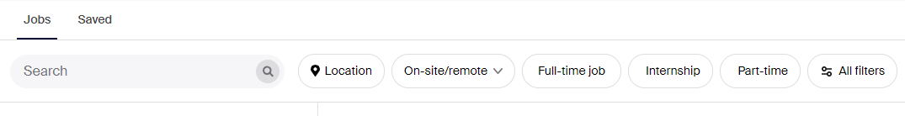
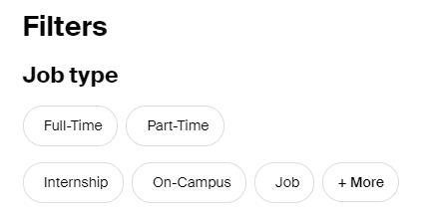
- Review summer on-campus positions and apply for those that interest you by following the application instructions in Handshake. You may not apply for positions marked Work Study Eligible Only.
- When hired, your supervisor will complete the bottom portion of the application form and will return the signed form to the Financial Aid Office. Electronic signatures are acceptable.

NOTE: Supervisors can email completed form to financialaid@viterbo.edu.
Viterbo Summer Student Employment Application

Student Section
Name: _____________________________________________________________________
Street Address: _____________________________________________________________
Phone Number: ___________________ Email Address: ________________________
Academic Major: ________________________ Expected Grad Date: _________________
Number of Hours per Week you are available to work: ______________
Are you available to work May – August? Yes No
If “No”, what are available dates? ______________________________
Have you had Summer Employment or Federal Work-Study before? Yes No
If “Yes”, in what departments? ___________________________________________

My electronic signature below certifies that I am a continuing student who will attend Viterbo in the coming fall semester. I understand that because Summer Employment is funded by the University and not Federal dollars, completion of an application does not guarantee a job; and hiring will be done by individual supervisors based on interviews and available hours.

Student Signature: ___________________________________ Date: __________________

Supervisor Section
Name: ______________________________ Department: __________________________
Number of hours per week above student is hired for: ___________
Work Date Range: ___________________________________________________

My electronic signature below certifies I have been in contact with the above student and have agreed upon the weekly hours and work range listed.

Signature of Supervisor: ___________________________________ Date: _____________

